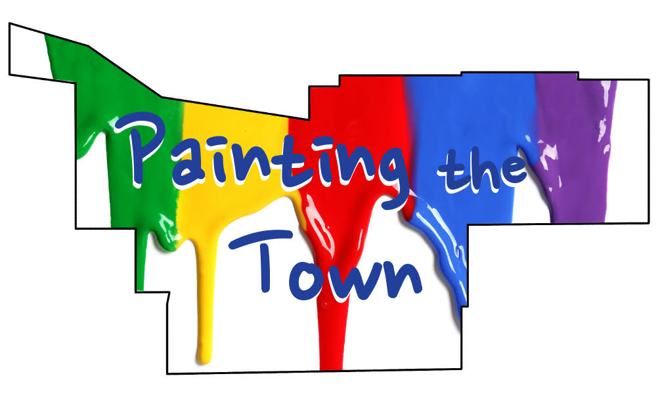
Painting the Town Utility Box Design Application Form

Due via email no later than
Friday 14 June at 5pm

Artist’s Name

Email

Street Address / City/Zip Code

Contact Phone Number

Web Address

Brief description of utility box design:

By signing this application, I agree to the terms listed in the Call for Artists.

_________________________________________________________ ____________________
Signature Date

