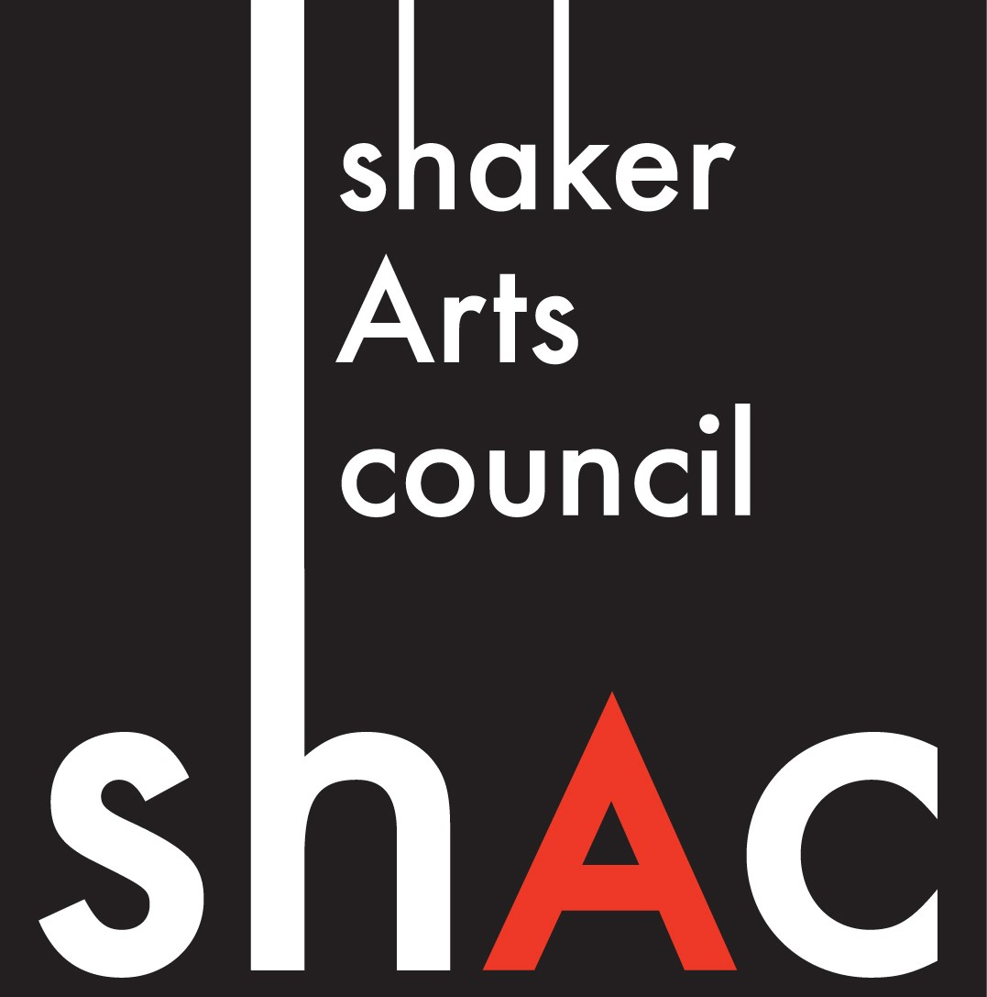
PMB 232, 16781 Chagrin Blvd., Shaker Heights, Ohio 44120
info@shakerartscouncil.org www.ShakerArtsCouncil.org 216-916-9360

Art Class Proposal
Stay -in-Place Productions
Entries will be reviewed upon receipt. Deadline: June 25, 2020
Submit by Email: info@shakerartscouncil.org
Classes will be scheduled during the month of July 2020
One application per class proposal

Application Date: / /

Dates/Times in July you cannot teach: ______________________________________________________

Contractor/Instructor Contact Information:

First Name Middle Initial Last Name

Address: ______________________________________________________________________________
Street City State Zip Phone:( ) - Cell Phone: ( ) -
Email Address: Web Address:___________________________

Course Proposal Information:

Program Name: ________________________________________________________________________

Length of Course: Hours per session - ___________ Number of sessions 1 2 3 5

Target Audience: (Check all that apply)

Adults Teens Youth Preschool All Ages

Program Description:
(Limit to 50 words; describe the course as you wish to see it in the promotional material)

Required Supplies:

Class size:
Target Number of Registrants: Minimum Number: Maximum Number:

Course Fees: $10/1 or 1.5 hour class; Instructors will receive 60% of tuition receive

Instructor Qualifications:
Brief Biography: (Limit to 50 words, as you wish to see it in the promotional material)

Experience:
Relevant Education/Training/Certification
  - Education/ training /certification, including date:

  - Education/ training /certification, including date:

Teaching Experiences relevant to this course
- List Experience, including date

- List Experience, including date

Have you taught this program before? Yes No
If yes, please list the locations and the years taught: ___________________________________________

Reference
Provide the names of one individual who can vouch for your qualifications:

Reference:
First Name Middle Initial Last Name
Phone: ( ) - Cell Phone: ( ) -
Email:
Relationship:

By signing below, I confirm that the information above is correct to the best of my knowledge, and I will provide the services described in this proposal as described herein.

Signature Printed Name

